**Purdue Airport in Unreal Engine**

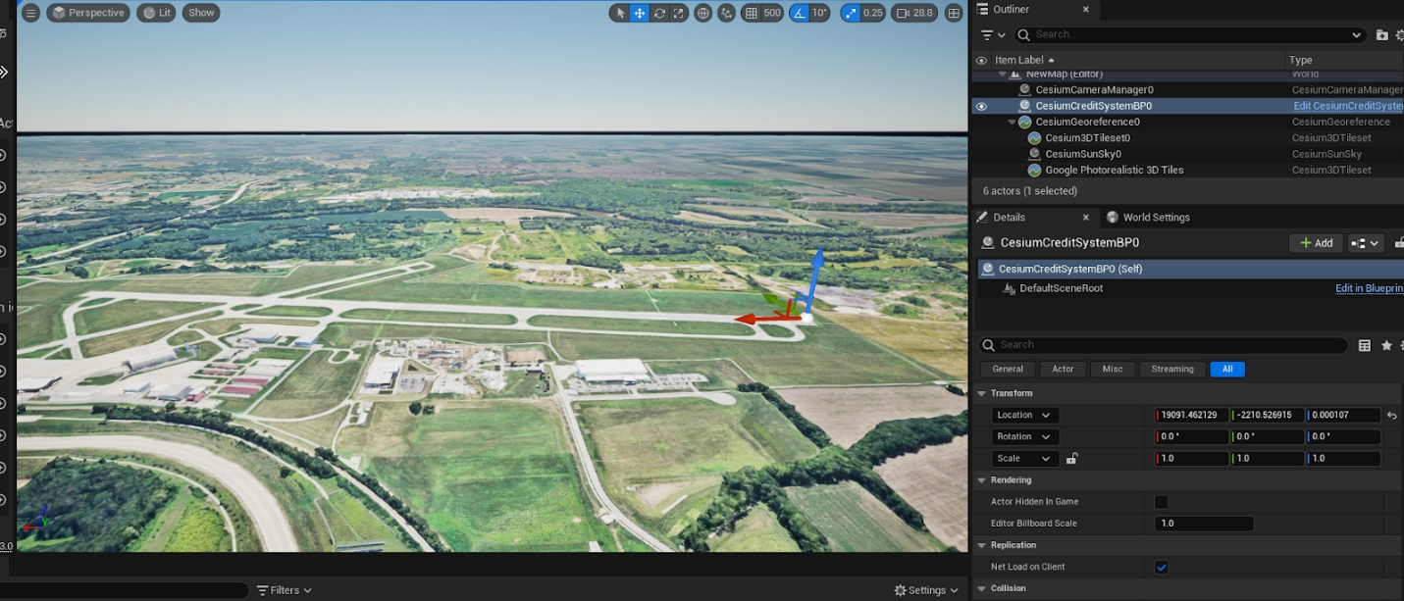

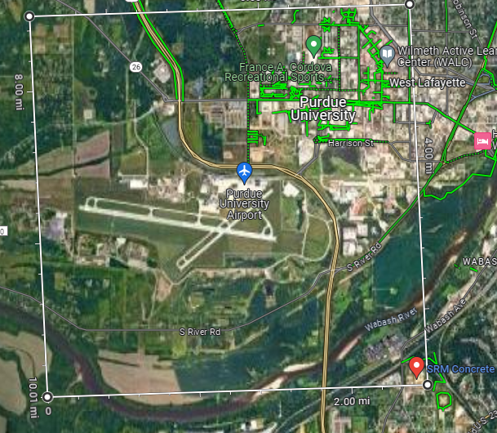

Note: when importing the selected grid cesium automatically rotates the plane. This is why the box is slightly tilted. Also, when important the plane I scaled the size to 20 in the x and y direction which resulted in 2.5 mi between the corners of the plane.

Further, when using the cesium plugin coordinates are translated from lat/long into unreal engine units. Lat and long are only used to travel the world after it is important. But placing objects in done in unreal engine units.

**Corner Locations**

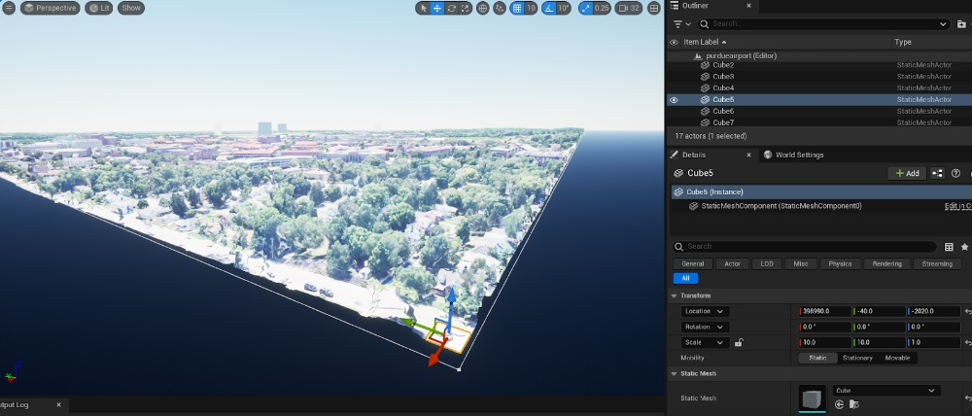

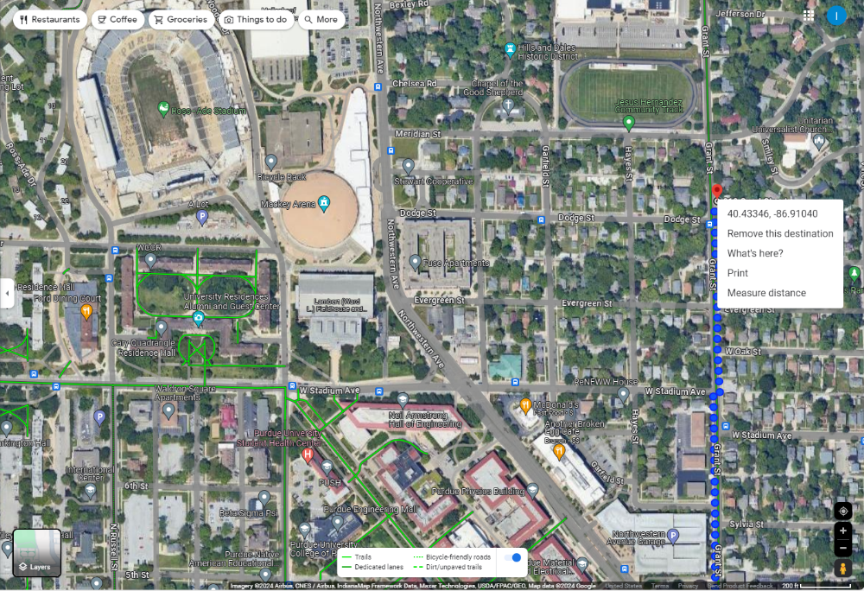

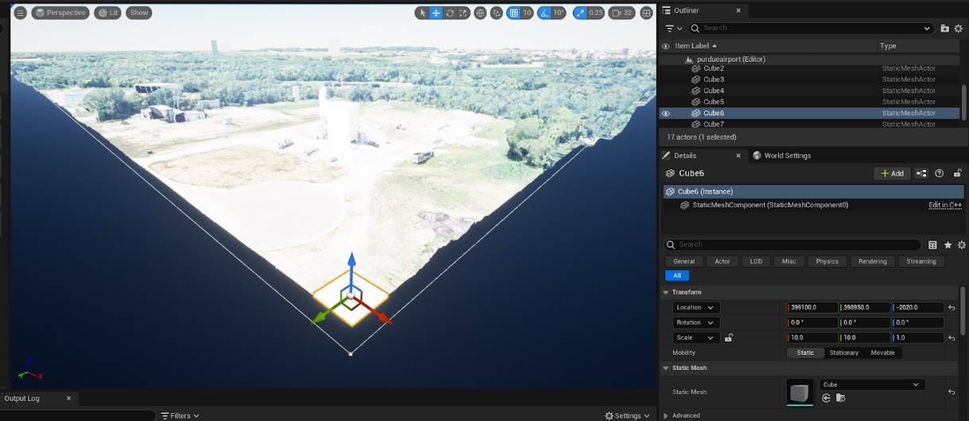

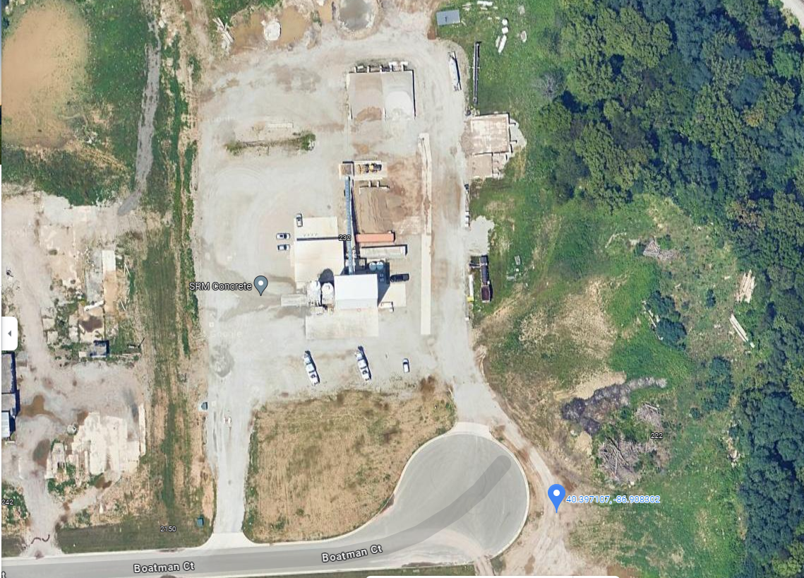

ORIGINGEOPOINT (in my map)

I found that the coordinates depicted in unreal engine are reference to how far they are from the origin geopoint which can be set by the user to any location on the map. It can also be left at the original geopoint of 0 lat and 0 long.

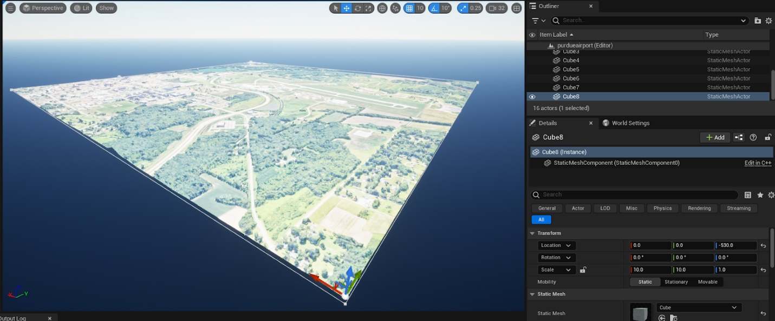

**Measurements of runways**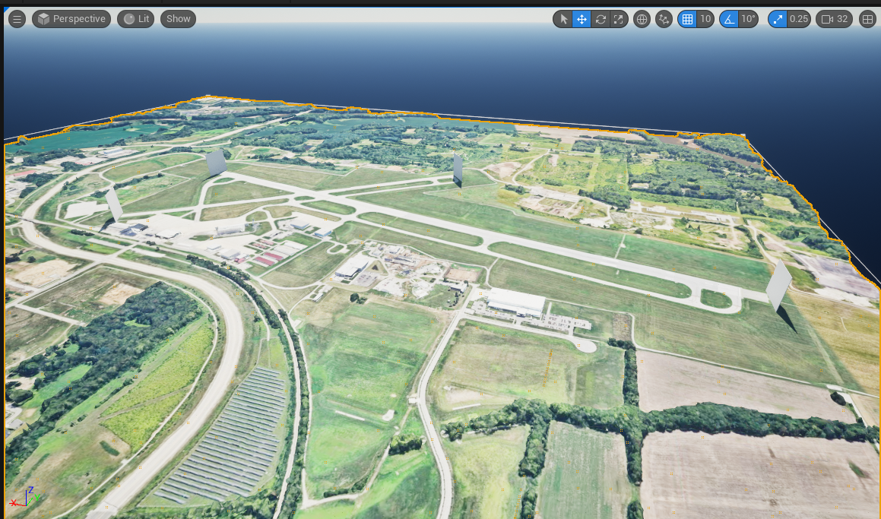

Longer runway measurement (2057m)

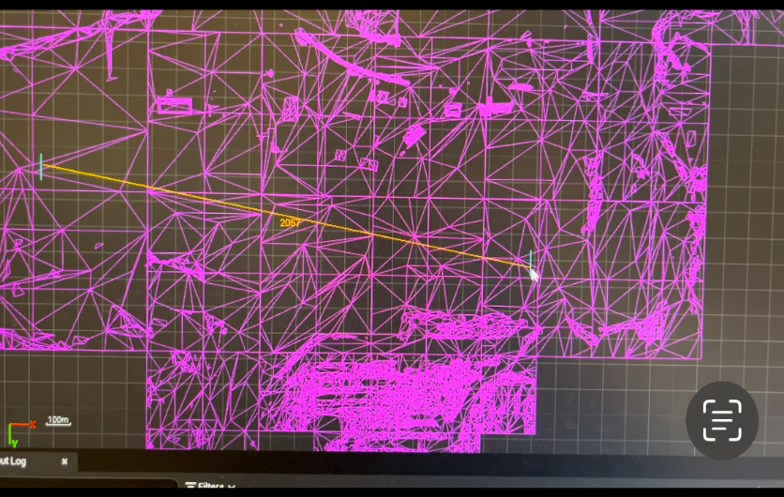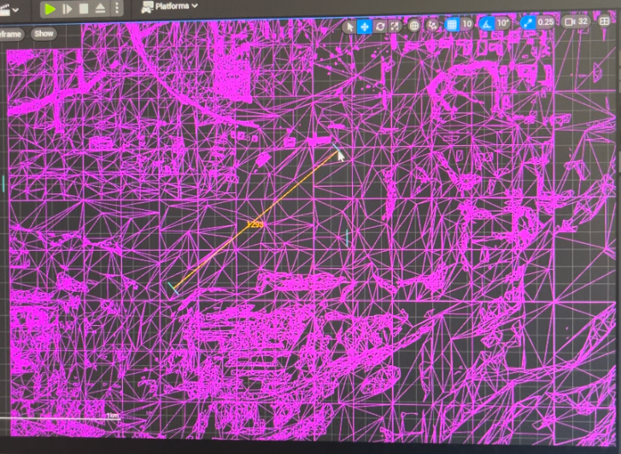

Shorter runway measurement (1293m)

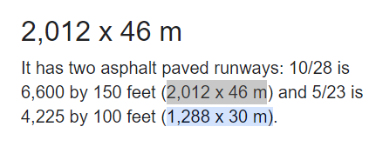

Note: to measure these runways I placed objects (planes) on both sides of the runway. Then I switched to a top view which allowed me to access measurement tools in Unreal. So, I measured the distance between the planes with the provided tool. I changed the units to meters before measuring.

**Coordinates in Unreal with their locations on google maps.**



